DOKUMEN |  | Nama | : .......................................................
SANGAT RAHASIA |  | Nomor | : .......................................................
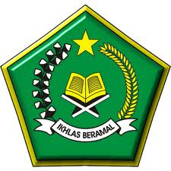
KEMENTERIAN AGAMA
KELOMPOK KERJA GURU MADRASAH IBTIDAIYAH VII KAB. DEMAK

ULANGAN AKHIR SEMESTER (UAS) GASAL MADRASAH IBTIDAIYAH

TAHUN PELAJARAN 2017 / 2018

Mata Pelajaran : Bahasa Inggris Hari / Tanggal : Jum’at, 8 Desember 2017
Kelas : V ( Lima ) Waktu : 08.45-10.15

- Choose the correct answer by crossing (X) A,B,C, or D!

- I usually ... at five o’clock.
- Gets up
- Get up
- Goes
- Go
- Risa : “Do you like jogging?”
Ulfi : “...”.
- Yes, I am
- No, I do
- Yes, I do
- Yes, I like
- Ryan always has ... at noon.
- Lunch
- Breakfast
- Dinner
- Supper
- I ... the floor every morning.
- Listen
- Sweep
- Cook
- Write
- It is ....
- Four o’clock

- Four past two
- Four past twenty
- Twenty past four
- Deni wants to play tennis. He needs a ....
- Book
- Doll
- Racket
- Marble
- The student usually have flag ceremony on ...
- Sunday
- Friday
- Monday
- Tuesday
- They are .... a book in the library.
- Buying

- Drawing
- Listening
- Reading
- Indonesian people celebrate independence day on ....
- July
- August
- September
- October
- Laila ... at nine o’clock after studying.
- Goes to bed

- Sweeps the floor
- Studies
- Has dinner
- What time is it?It is ....
- Ten o’clok
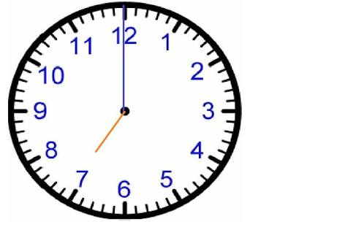
- Nine o’clok
- Eight o’clok
- Seven o’clok
- Before having dinner, Ayyubi always ....
- Takes a bath
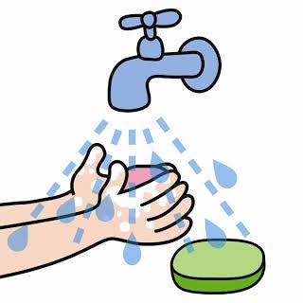
- Washes his hands
- Brushes his teeth
- Washes his feet
- There ... seven pencils in the pencil box.
- Is
- Am
- Are
- Was
- Before you go to bed, brush your ....
- Face
- Lips
- Hair
- Teeth
- We like to play ... together.
- Tug of war
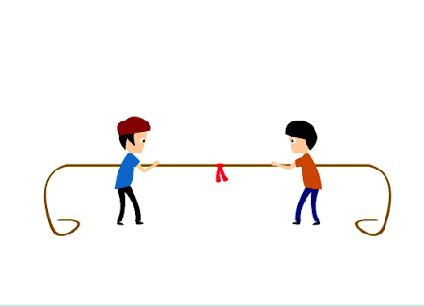
- Marble
- Chess
- Hide and seek
- My hobby is ....
- Dancing

- Singing
- Playing
- Walking
- We need a ball to play ....
- Football
- Badminton
- Catapult
- Doll
- Nilna : “Lend me your bolpoint, please!”
Lisa : “I’m sorry, ....”.
- This is it
- Here you are
- I’m using it myself
- Yes please
- My sister always wears ....
- T-Shirt
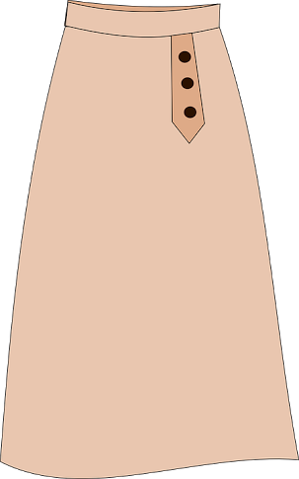
- Jacket
- Short
- Skirt
- My brother like to eat ... for breakfast.
- Bread
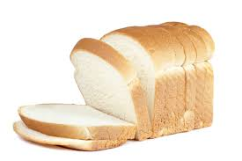
- Soup
- Porridge
- Noodles
- My father always drink a cup of ... in the morning.
- Milk

- Tea
- Coffee
- Juice
- Oji : “What do they wear for swimming?”
Azza : “They wear ... “.
- Blouse
- Pijamas
- Swimsuit
- Jacket
- The students wear their ... to school.
- Uniform
- Jeans
- Culot
- Sweater
- playing-hide-They-seek-and-are
- They are playing hide and seek
- Playing hide and seek they are
- Seek and hide they are playing
- Hide and seek they are playing
- Luna : “Are these your marbles ?”
Dimas : “No, ...”.
- It is
- These are
- This is not
- These are not

- Fill in the blank by using the word in the right side !

- I always ... my teeth after breakfast.
- The students ... to school by bicycle.
- My mother ... apples in the supermarket.
- We want to ... basket ball.
- Ulin likes playing kite. His ... is flying so high.
- There are ... months in a year.
- Carrot and spinach are the names of ....
- Let’s play snakes and ladders. OK, ....
- Salma’s hobby is .... Her voice is very beautiful
- The girls like to play ....
- Play
- kite
- Go
- Singing
- Brush
- Let’s do
- Buys
- Doll
- vegetable
- Twelve

- Fill in the blank with the correct word!

- Today is Monday, yesterday was ....
- I want to sleep, I must wear my ....
- 12:30 in English is ....
- We wear ... in cold weather .
- Rudi takes a bath ... a day.

- Answer the following questions !

- What time did you get up?
- When do we celebrate our independence day ?
- football-favorite-is-our-game.
Arrange the words into the good sentence!
- Mention 3 names of games !
- My family eat at restaurant.
Translate into indonesian!

